Constructing a Learning Environment that Promotes Reinvention

Els Feijs
Freudenthal Institute
University of Utrecht
The Netherlands

Research Framework

The research described in this article relates to student materials that are developed for American middle schools as part of the Mathematics in Context (MiC) project. This project was a collaboration between the Wisconsin Center for Education Research, School of Education, University of Wisconsin in Madison, United States, and the Freudenthal Institute at the University of Utrecht, The Netherlands, aimed at the development of a comprehensive mathematics curriculum for grades 5 through 8. The work was supported by the National Science Foundation. The curriculum as it was developed addresses the recommendations of the National Council of Teachers of Mathematics Curriculum and Evaluation Standards for School Mathematics (1989), with regard to philosophy as well as content.
In the collaboration the development of student materials primarily was the responsibility of the Freudenthal Institute. Both institutes were involved in classroom experiments, observation, inservice education, assessment, and research. Mathematics in Context, a five year project, was finished in 1998. In collaboration with the publisher of the curriculum materials two more years were spent on the development of teacher guides and other written support to go with the student books.
The complete Mathematics in Context program contains forty units, ten at each grade level. The units are organized into four content strands: number, algebra, geometry, and statistics. The research described in this study concerns the geometry strand of the curriculum.

Geometry in Mathematics in Context - philosophy

The geometry strand in the Mathematics in Context curriculum was developed by the Freudenthal Institute according to the principles of Realistic Mathematics Education (RME). Geometrical aspects of daily life contexts are used as a starting point; the education builds on students' informal experiences with such contexts. Students are expected to play an active role in the learning process; they construct their own knowledge, triggered among other things by classroom activities and manipulatives. Students are enabled to actually reinvent geometrical concepts by solving problems offered by teacher-guided reinvention (Freudenthal, 1973; Freudenthal, 1991, p.46). Reflection plays an important role in the learning process; students are urged to become conscious of their experiences and to describe and understand these in mathematical terms, for example by making own productions (Streefland, 1990). In order for students to learn from interaction there is plenty of room for students to communicate with other students. And, finally, there are many connections within the curriculum, not only within the geometry strand - in which knowledge is built on units students have done earlier - but also across strands - for example number skills are frequently required in the geometry strand, and there are many connections of geometry with algebra and statistics as well.

The overall goal for the geometry curriculum that was developed for American middle schools is Freudenthal's idea of 'grasping space': " ... geometry is grasping space. ... it is that space in which the child lives, breathes and moves. The space that the child must learn to know, explore, conquer, in order to live, breathe and move better in it." (Freudenthal, 1973, p.403). Activities aimed at 'grasping space' are abundant in the student materials. As for the content of the geometry strand, more traditional subjects are embedded in a way which suits realistic mathematics education, and a very important role is given to what we call 'vision geometry.' Vision geometry deals with the relationship between representations of reality and reality itself, and the role of vision in this relationship (Team W12-16, 1992, p.27).
This emphasis on vision geometry follows a long Dutch tradition which is rooted in the innovation of geometry education which was initiated in the beginning of the seventies by the Institute for Develoment of Mathematics Education (IOWO). Besides Freudenthal as a source of inspiration we should name especially the pioneering work of Goddijn, Schoenmaker, De Lange and Kindt (Schoenmaker, Goddijn, De Lange & Kindt, 1981). For American schools, where the standard Euclidian Geometry curriculum is still prevailing, this approach is totally new. In our opinion this justifies the choice of geometry as a research subject.
Finally, we should remark that within the boundaries of the Mathematics in Context project there was a certain amount of freedom for the Freudenthal Institute regarding the development of the curriculum, however this freedom was limited in certain respects. The curriculum had to be in accordance with the NCTM Standards and with a Blueprint document (Romberg, 1992) written by the advisory committee of the project, and the development took place in a dialogue with the American staff on the project team.

Geometry in Mathematics in Context - the curriculum

Three themes run through the geometry curriculum: 1) orientation and navigation; 2) shape and construction; 3) visualization and representation. These themes determine the focus and direction of the geometry strand. Although units may emphasize one theme over the others, no theme is completely absent in any unit.
The first theme, orientation and navigation, is of a dynamic character. The student is placed at the center of space, and geometry is considered to be the study of the student moving through space. One aspect of orientation has to do with realizing your position relative to other objects and the consequences for seeing those objects. Another aspect of orientation is realizing your position relative to a certain direction and distance to a certain point and the possibilities to use coordinates and vectors. Navigation includes the use of coordinate systems to represent positions, the use of directions and distances to design routes and to locate places, and the use of changes in directions to define angles and turns.
The second theme is of a more static nature, the focus being on characteristics of objects in the student's space. Some of the topics are shape identification and classification, shape in design and building, two and three dimensional shapes and their relationships with each other, similarity and congruence, abstract models of shape that highlight important features like edges, vertices and faces, lines with special properties, and transformations. Construction involves the active manipulation of shapes by the student. Some related topics are constructibility of triangles, tiling, constructing solids, and design and construction of maps. The more traditional subjects in geometry can primarily be found in this second theme.
The final theme, visualization and representation, is pervasive in the geometry strand. It can be found not only in geometry but in many other subject areas in mathematics as well. Visualization and representation have to do with what you see and how you see it and how you can communicate that to other people. Example topics are two dimensional representations of three dimensional objects, projections, side/front/top views, maps, nets, cross sections, contour lines, vision lines, networks and graphs.

The geometry curriculum is organized in ten units for four grade levels. Each of the units concentrates on a more or less confined subject. It is structured by mathematical subject rather than by context in which the mathematics is presented. All ten units are connected. The unit titles are listed in Figure 1 and the arrows show the connections between units.

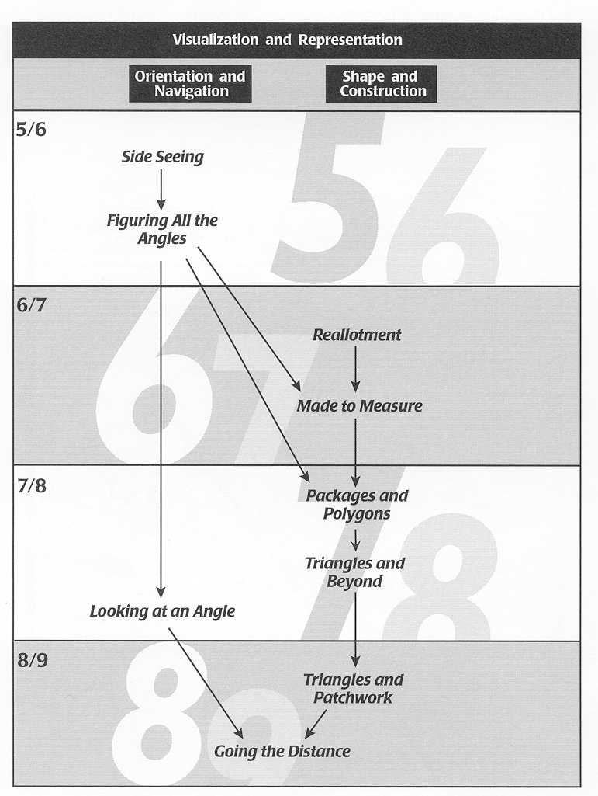
Figure 1: The Geometry Curriculum in Mathematics in Context

The research described in this article is restricted to the unit 'Looking at an Angle' which was designed for grade 7 (12 through 13 year olds) (Feijs, De Lange, Van Reeuwijk , Spence & Brendefur, 1998).

Research Problem

The initial research question was, in general terms: Is it possible to translate the philosophy of realistic geometry education as described above into student materials?; how to develop such curriculum materials?; and how effectively can these materials be taught in American schools? Since it was impossible to answer this research question in relation to all of the geometry curriculum materials a selection had to be made. After a small scale pilot in several American classrooms the unit 'Looking at an Angle' was selected, since it seemed most suitable for the following reasons. The developers of Looking at an Angle have tried to incorporate all significant characteristics of realistic geometry education in the design of this unit. The unit is characterized by a large variety of learning settings, a broad mathematical content, and a rather complex structure of this mathematical content. A large degree of student input is required so it was to be expected that this unit would generate a considerable amount of student materials for analysis. The mathematical content is for the most part completely new to American mathematics teachers in the middle grades, which would justify a study into their experiences. And, last but not least, early experiences with this unit in classrooms showed that the resulting students' learning processes were interesting from a developmental perspective. In other words, there was plenty of room for improvement in the sense that the original design should be subjected to a cyclic process of design and research.

The initial research question now is focused on the unit Looking at an Angle. Several more specific research questions have arisen as a result of classroom experience with this unit, such as: 1. To what extent does reinvention actually take place and how can reinvention be promoted? 2. What are the effects of the chosen realistic contexts on students' learning processes? 3. What is the role played in the learning process by hands-on experience and hands-on materials? 4. To what extend are mathematical connections that are implicit in the materials visible to students? 5. In what way does the student material elicit student reasoning and the making of connections by students? This chapter focuses on the first research question, that is the feasibility of reinvention as a designer's goal.

Research Methodology

This study can be characterized as developmental research. The goal, as described by Freudenthal, is to "consciously experience, describe and justify the cyclic process of development and research so that it can be passed on to others in such a way that they can witness and relive the experience." In this process the thought experiment plays an important role: it is at the base of the curriculum design. The designer of the curriculum tries to envision how a teaching-learning process will proceed and uses classroom experiments to search for indications whether or not the expectations were correct. This will lead to new thought experiments that will induce an iterative process of development and research.
In this research the design principles and the goals of the pilot version of the unit Looking at an Angle were made explicit as much as possible, the design was piloted in classrooms, observation reports were analyzed and the materials were revized and piloted again in an iterative process. During each stage of the design student learning processes were analyzed in order to find indications for the revision of the materials. Especially learning processes that were not anticipated proved interesting in the sense that they often indicated the need for revision.

There are two main sources of data collection in this research study. Firstly, the curriculum materials themselves in all different stages of the development process. Data collection is focused on making the implied local instruction theory explicit and describing it.
Secondly, the data collected through classroom experiments. The unit Looking at an Angle was piloted at a number of American middle schools, and after revision tried again, not only at American schools but also at a school in The Netherlands. Lessons were audio and video taped, classes were observed extensively, with emphasis on students' thought processes that were generated by the student materials and influenced by the teaching methods chosen by the teacher. Observation notes were worked up to detailed lesson reports. Video and audio tapes were transcribed. Transcripts include conversations between students and the researcher who sometimes acted as a participant observer with small groups of students. Data collection also included written student materials and answers to questionnaires that were developed for students for research purposes. Finally, interviews with teachers who taught the unit are used as background materials to evaluate and validate research findings. All data mentioned above were analyzed in an iterative process that is to a large extend similar to the 'constant comparative method' described by Glaser en Strauss.

Structure and Content of the Unit

In the Mathematics in Context curriculum, the concept of angle was introduced two years earlier in a unit called 'Figuring all the Angles.' In the dynamic context of navigation students discover that an angle can be perceived as a turn, that is, a change of direction. Next, they learn how to measure angles using a compass card, also in the more static context of geometric shapes. In grade 7, Looking at an Angle is meant as a follow up unit. The focus now is on a special angle: the angle of elevation. In connection to this angle, the concept of tangent is introduced. Through several other units in the geometry and other strands students supposedly have developed a number of skills and concepts which can now be considered to be basic knowledge to them. These skills and concepts are related to views (front, side, top), triangles (also right triangles), altitude, area, graphs, ratio and proportion, fractions, percents and decimals.

The backbone of the unit Looking at an Angle consists of five different contexts which all have the same mathematical structure, that is, the right triangle. The unit starts with the concept of vision lines (or lines of sight) in the context of the Grand Canyon. How can vision lines be used to determine whether or not the river at the bottom of the canyon can be seen from the rim? In this situation it is important to consider the steepness of the vision line and the presence of objects that might block the view. Figure 2 shows a side view of the situation. The eye of the person looking toward the river is at point A, point B shows a ledge of the canyon wall, and at point C the vision line touches the ground.

A

B
C

Figure 2: Vision Line in the Grand Canyon

The concept of vision line is further explored in a second context, that of boats, in order to investigate the concept of steepness and to discover regularities in the ratio between the height of the object blocking the view and the length of the resulting blind area. This situation can again be pictured as in Figure 2, provided that now point A represents the eye of the captain on the boat, point B represents the bow of the boat, and point C indicates the border line between the area that can be seen and the area that cannot be seen by the captain.

A third context makes a connection with shadows. If the eye of a person looking at an object is replaced by a light source the blind area becomes visible as a shadow. Students may now use construction drawings to investigate the direction, the shape and the length of shadows. Also, they discover differences between shadows caused by a nearby light source and shadows caused by the sun. Similarly, in this context the right triangle as a representation is used to grasp the situation, provided that now the vision line is replaced by a light ray.

A fourth context concerns the steepness of ladders. Students come to understand that steepness can be expressed by means of the size of the angle between the ladder and the ground and by means of the ratio between the height the ladder reaches on the wall and the distance between the wall and the foot of the ladder. This ratio can be expressed as a fraction or as a decimal. Again, the right triangle can be used to represent the situation, as shown in Figure 3.

Finally, the context of hang gliding is introduced in order to further develop and formalize students' concepts of steepness into the concept of tangent. The performances of different hang gliders are compared by means of the so-called glide angle and by means of the ratio between the height the glider is launched from and the distance it flies measured along the ground. Or, by means of the tangent of the glide angle.
The situation can again be visualized as shown in Figure 3.

height

ladder

α
distance

Figure 3: The Steepness of a Ladder

So far a short description of the structure of the unit design as it eventually crystallized. However, before the unit got its definite shape it went through a long and extensive process of design, experiment and revision. The following paragraphs will describe this process into detail.

Guided Reinvention and Didactical Phenomenological Analysis

As indicated above one of the leading principles in the design process was that of 'guided reinvention.' According to this reinvention principle students should be given the opportunity to experience a process similar to the process by which mathematics was invented. It implies that by solving a carefully designed 'real' problem students develop 'new' mathematical concepts. This solving can be done in a very informal way with very informal language as well, but quite often, during the process, students sharpen both the concept and the language to describe it.
In the case of this particular unit, Looking at an Angle, it was indeed the intention that students themselves would reinvent mathematical concepts. At a macro level the mathematical content involves ratios in a right triangle related to an angle, in connection to the concept of steepness and on an abstract level resulting in the concept of tangent. But also on a micro level this is the leading principle as to contexts in which the concept of tangent may come up, such as contexts in which vision lines or shadows play a role. In this paragraph the macro level will be discussed. The next paragraph will focus on the concept of vision line on a micro level.

It is the task of the developer to design a learning trajectory that will enable students to reinvent the mathematical concepts, in doing so finding inspiration in the history of mathematics and/or in informal strategies used by students. It is crucial to select contextual problems which offer a wide array of solution strategies and which hopefully give an indication of a possible learning trajectory through progressive mathematization as a starting point for the learning process.
The didactical phenomenological analysis as described by Freudenthal plays an important role in the design process. This analysis considers situations in which the mathematical concept concerned is applied, in the first place because it has to be made clear in education where the concept is applied and, in the second place, their suitability to promote the process of progressive mathematization has to be evaluated. In other words, a selection has to be made of situations that will elicit the development of paradigmatic solution strategies that can be generalized.

A didactical phenomenological analysis was indeed carried out in the early stages of the development of the Looking at an Angle. As far as the mathematical content is concerned a preset goal of the unit was the development of the abstract concept of tangent and the concept of steepness. It already was common knowledge that the context of hang gliding was very suitable for this purpose, based on the successful experiences with a previous unit – developed at the predecessor of the Freudenthal Institute, the IOWO - 'Vlieg er eens in' which was the primary source of inspiration. Just like in that early unit the concept of tangent was to be developed by investigating the relationship between the glide ratio (the ratio between the height a glider is launched from and the distance it flies measured along the ground) and the glide angle. However, it was the aim of the developers to include several other fields of application in the unit, and to let students reinvent the concept of tangent more gradually in a broader context, namely that of ratios in a right triangle in connection to an angle. For that purpose several contexts were selected in which steepness or angle of elevation were key concepts. From a first collection of possible contexts a selection was made on the basis of the didactical experience of the designers. The main criterion for the selection was the variety of phenomena of the mathematical concept steepness. Eventually the designers chose for the following phenomena: steepness of vision lines, steepness of light rays, steepness of objects, and steepness of roads. A more or less simultaneous step in the design process was the search for daily life context situations that would fit these phenomena, in other words the translation of mathematical phenomena into concrete situations. Now, the main criteria were the familiarity and appeal for students. This selection process resulted in the following choices: steepness of vision lines is elaborated in the context of the Grand Canyon and that of boats; steepness of light rays is investigated in the context of a search light shining from a fort onto tree stumps behind which people are trying to hide; steepness of objects was translated into the context of ladders; and finally the steepness of roads was translated into the context of hang gliders. The order in which these contexts are presented is not random but it is based on an imaginary learning trajectory in which progressive mathematization is to take place.

In 'Looking at an Angle' one of the first goals is reinvention of the vision line. This concept seemed most suitable as a starting point because all students are familiar with situations in which you can or cannot see objects or persons (think of games such as peek-a-boo or hide-and-seek) and because it allows for a broad exploration. All students know by experience that sometimes your view is blocked by an object or person. To determine whether or not something is visible it may be necessary to make a sketch of the situation. After exploring several situations students are stimulated to make such a sketch, which will look like a right triangle the vision line being the hypotenuse (see Figure 2). Having discovered this, students have a model on which they can build throughout the remainder of the unit. In the context of vision lines students have found a model which at the beginning is still closely connected to the context but which later on in the unit may be used for mathematical reasoning. In other words, as described by Gravemeijer, a model of a situation can become a model for that situation through an ongoing process of generalization and formalization. In this approach the model is used as a mediating tool to bridge the gap between situated knowledge and formal mathematics.
At the beginning of the unit the term 'vision line' may remain unnamed. Students first implicitly explore the concept of steepness by investigating what happens in case the location of the person looking changes, or in case the object blocking the view is moved to a different location. However, in the context of boats it becomes necessary to name the vision line as well as the area that cannot be seen ('blind spot' or 'blind area'). The reason is that in this context questions are asked which focus on the relationship between the angle of the vision line and the water surface on one hand and the dimensions of the area that cannot be seen by the captain of the boat on the other. Such questions demand a precise construction of vision lines – again using the right triangle as a model of the situation – the measuring of the angle of elevation – without being named as such – and the measuring of the length of the blind area. In doing so students will discover that if the angle of elevation is small the blind area will be long and as a consequence the captain's view will be poor. The context of boats is not only used to refine students' terminology and ability to make precise drawings, it also offers splendid opportunities to explore the relationship between height, distance and angle of elevation.
At first such an exploration takes place by means of toy boats, the captain's vision line being materialized by a piece of string. Then, by using a model of a tug boat made of cubes and skewers to model vision lines it becomes possible to make a precise construction of the blind area and to discover numeric relationships between the exact height of the captain and the length of the blind area. Also, the relationship between the shape of the blind area and the shape of the bow of the boat is clarified. Figure 4 shows how the blind area of the captain of a tugboat can be constructed by drawing vision lines.

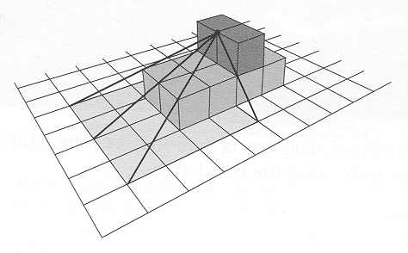
Figure 4: Vision Lines of the Captain of a Tug Boat

As the context of the fort and the tree stumps is introduced we move away from the subject of vision lines. However, the contexts involved are isomorphic. Sketching or constructing vision lines and blind areas is done in basically the same way as sketching or constructing light rays and shadows. The reason to introduce this new context is that it very well suits a deeper exploration of the concept of steepness. For example, in dealing with shadows caused by the sun it may be determined that at a certain moment and at a certain place there is a constant ratio between the height of an object and the length of the shadow of that object, since all sun rays are equally steep and the angles between the sun rays and the earth's surface are all the same size. There are plenty of discoveries related to the concept of steepness to be made by students investigating shadows caused by the sun. Also, they may compare their observations with what happens if shadows are caused by a nearby light source. Certainly not all of the mathematics in this shadows chapter is necessary for the core learning trajectory of this unit. Along the way students reinvent other mathematical concepts which fit into the MiC curriculum.
With the introduction of the context of ladders an important step is made in the process of progressive mathematization. The context in itself is fairly bare. A ladder leaning against a wall in a side view looks like a right triangle. There are no more objects blocking the view or casting shadows. There is only height (where the ladder touches the wall it is leaning against), distance (between the wall and the foot of the ladder), hypotenuse (the ladder itself), and the angle between the ladder and the ground. The context itself provokes a discussion of steepness, since this is relevant in thinking about a safe positioning of ladders. As a consequence, in this stage of the learning trajectory it is natural to start focusing on the construction of right triangles in order to investigate the relationship between height, distance and angle of elevation. Formal notation is introduced and for the first time in the unit the term steepness is mentioned.
Toward the end of the unit the context of comparing the performances of different hang gliders is used to make the step to the formal concept of tangent. As already said before, the context in earlier experiments had proved to be very suitable as 'model for.' As soon as students have discover that the performance of a hang glider can be expressed by means of the 'glide ratio' (the ratio between the height the glider is launched from and the distance it flies measured along the ground) or by means of the glide angle, the step toward the formal concept of tangent is merely a matter of terminology and notation.

So far the description of the hypothetical learning trajectory. In retrospect we may state that in its original form it looked quite simple, meaning that before and during the initial development the designers did not yet have a very clear and detailed picture of how the unit was going to be structured. In the initial design phase a refinement of the learning process as envisioned took place. However, there was a constant danger of following side paths that were touched upon, thus neglecting the larger structure. For instance, it would have been possible to dedicate a complete unit to the subject of shadows. Also, during the design process there were moments of doubt about the structure of the unit and the order in which contexts were to appear. For example, it was discussed whether or not it would be better to have the reinvention of vision lines be preceded by the exploration of shadows. Besides, a number of context situations in which mathematical concepts on side tracks are applied had to be left out of the unit because there simply were too many and because they would obscure the flow of the unit.
The final product was created through a long process of deliberation in which classroom experiments, observations and analysis played a crucial role. However, this has not only led to a final product but also offered possibilities for an ongoing refinement of the hypothetical learning trajectory. In other words, the designers/researchers through this process became more and more able to describe and justify the underlying structure of the unit under design. Or, better, the many structures and connections, considering that classroom experiments have shown that students saw connections and structures that were not consciously brought into the unit but that nevertheless fit in very well. We may conclude that being simple in its original form the curriculum design has turned out to be rather complex.

The original structure of the unit has survived. It was not effected by all the changes that have been made. Based on classroom experiments we may conclude that at a macro level the goal of reinvention can indeed be attained. The chosen contexts attribute to a gradual reinvention of the concept of steepness and eventually the concept of tangent. Note, however, that not all students reach the highest level as far as tangent is concerned. For some students the step toward working with tangent on a formal level is too big. They feel more comfortable thinking at a level on which the model of the right triangle refers to a well know situation, such as that of a glide ratio in the context of hang gliders.
The development process has shown that the structure as described in the hypothetical learning trajectory was not always that obvious to the developers themselves, but that it also at times remained obscure to students. As a result in the final product connections between the various contexts featuring in succession in the unit have been made more explicit to students. Mind that the word 'guided' in 'guided reinvention' does not only apply to curriculum designers. It is also the teacher's duty to regularly have discussions with students aimed at reflection on the ongoing learning process in order to keep the main ideas and the flow of the unit in mind. Below are several examples of students' written reflections on the first two chapters of the unit, showing that students are indeed very well capable to put into words the connections they see between different contexts.

'They (are) all related because they all use mathematical figurations to get an answer. They all have something to do with a view point and where you can or cannot see. All form right triangles and all use ratios.'

'I think the activities we've done are related because they all had to do with blind spots and lines of vision or light.'

'All of the activities this far are related because they all show vision lines and blind areas. Each activity showed a person's view of something from where they were standing. It also showed what they could see and what they couldn't see.'

'All of them have to do with vision lines. Someone's blind spot if they are in a certain spot. How you can see more or less if your position or height is moved. (...) All blind spots form a right triangle. The larger the angle the smaller the blind spot.'

So far for reinvention on a macro level. In order to draw conclusion about reinvention on a micro level we will now refer to the beginning of the unit Looking at an Angle, where students are put on the track to reinvent the vision line.

Guided Reinvention of the Vision Line

After it was decided to use situations in which vision lines are important as an introduction to the unit, the question was how to put students on the track to reinvent the concept of vision line. The developers thought this could be accomplished by presenting photographs. The first version of the unit started with a photograph of a hiker on the rim of the Grand Canyon looking down trying to see the Colorado River at the bottom of the canyon. The question that went with the photograph was: Can the hiker see the river below? The photograph is shown in Figure 5.

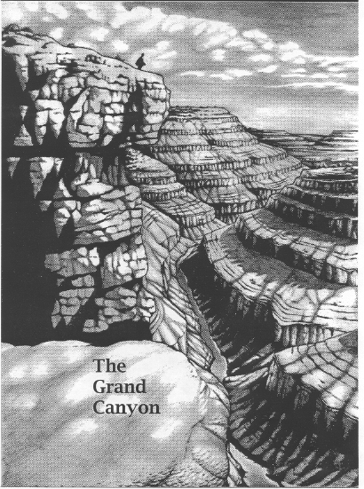
Figure 5: Hiker on the Rim of the Grand Canyon: Can the hiker see the river below?

It was meant to stimulate students to think about how to determine what you can or cannot see. It was followed by three more photographs and questions concerning the reason that the river cannot be seen on parts of the photographs.
Students were expected to naturally start talking about the view being blocked by protruding rock, implicitly discussing vision lines. Since most students would probably never have visited the Grand Canyon it seemed likely that some would have trouble interpreting the photographs. The developers considered it desirable to have students experience a three dimensional representation of the situation, and therefore the unit offers nets that could be used to make a paper model of the Grand Canyon with a curve in it. The assembled model is shown in Figure 6.
The model was intended to have students investigate from which places on the rim of the canyon the river would be visible. The student unit also showed side views of the model in which students could draw vision lines if they wished to do so. As soon as students would have discovered the vision line they could, based on the model, investigate ratios between heights and widths of the ledges of the canyon walls. Just in case students would not have invented vision lines by themselves, after a couple pages it was suggested to use knitting needles or skewers with the paper model to determine whether or not the river was visible from the canyon rim. The text said that knitting needles or skewers may serve as a model of vision lines: imaginary straight lines from the eye to an object. And from that moment on vision lines would be a concept understood by students, whether or not they reinvented it by themselves.

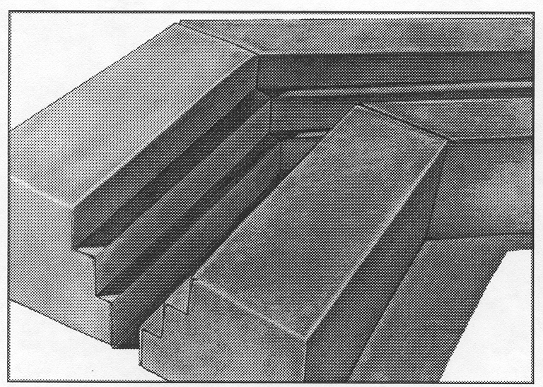
Figure 6: Paper Model of the Grand Canyon

Reinvention of the vision line did not take place during the first try-out of the unit. This may be attributed to the fact that the pilot teachers, who regretfully as a result of circumstances had not been well informed about the goals of the unit, gave away the idea of a vision line right at the beginning of the unit on the first page. As teachers noticed that students were not able to give a conclusive answer to the first question (Can the hiker see the river below?) they suggested to draw vision lines in the photograph. However, it is inappropriate to draw vision lines in a photograph that does not show an exact side view of the situation. Also, the student work shows that many students did not know how to draw vision lines nor had the faintest idea how drawing a vision line would help to answer the question. Some students drew a line from the eye of the hiker who seemed to stare straight ahead. Other students drew a seemingly random line going straight through rock. Of course the use of a paper model of the Grand Canyon in this situation could no more contribute to any kind of reinvention.

This experience clearly indicated some issues that are very important for the curriculum development process. First of all, it is very well possible that students are familiar with situations involving a blocked view, however this does in no way imply they are familiar with the concept of vision line. Second, the choice of photographs was very unfortunate if the aim is reinvention of the vision line, since photographs give a perspective representation of the situation and they are not suited to draw vision lines. Photographs are at best suited to elicit thinking about ways to determine what you can or cannot see. Third, it is not at all obvious that there is only one specific vision line that is crucial in order to determine what you can or cannot see, that is the vision line that goes from the eye exactly along the ledge of the rocks. The hiker on the rim of the canyon wall may look in all different directions. There are in fact numerous vision lines. And, finally, the wording of the questions was not precise enough. It was not clear to students that the hiker was not looking straight ahead but downward, in an attempt to see the river at the bottom of the canyon.
These conclusions called for a revision of the design of the beginning of the unit.

In collaboration with a teacher a new introduction was developed and tried in the classroom. The new introduction is as follows. The teacher discusses with his class that he is going to leave the room. While he is gone, the door will remain open. Of course students will start doing all sorts of things they are not supposed to be doing, and therefore it will be good to appoint a student as being the lookout to announce the coming back of the teacher. Now the question to the class is which student's position is most suited to be the lookout post, and why? After the students have written their prediction the teacher will actually leave the classroom and come back after a while, so that students may check whether or not their prediction was right.
This introduction was chosen because it was supposed to be close to students' implicit experiences with vision lines. Also, the intention was to make students aware of their implicit notions of vision lines through reflection. The classroom experiment that followed made clear that the first supposition proved correct: the situation was appealing and well known to students. However, the question is also, did the context elicit a discussion about vision lines? In the class discussion students did talk about for example "he does not see the door from the right angle," or "she looks straight through the door into the corridor," but on the other hand many of their suggestions obscured the issue. Such as, students suggested that they could get out of their seats and walk to the door, in which case students closer to the door could be back in their seats more quickly, or that students who are seated closer to the door can better hear the teacher coming back. In short, the situation was so recognizable to students and they got so involved in it that it was too hard for them to stick to the rules as described by the teacher. If it were for real they would, for example, not stay in their seats. The fact that the situation proved to be over-familiar had the effect that mathematical notions remained implicit in the class discussion. There was no reason whatsoever for students to put into words what everybody knows, that is that people look in a straight line and cannot look around a corner or through a wall.
The situation with the teacher leaving the room did fulfill a role in the sense that the students became aware of a phenomenon they had often met but had never reflected upon. The learning effect was however limited because students handled the 'problem' as a real and relevant problem, which solution consisted of a series of very practical and effective strategies – none of them necessitating the vision line. Therefore further rethinking on the part of the designers became necessary. But the experiment did give certain indications for a different revision of the unit.

The starting point for revision was that students had to be enabled to explore a three dimensional situation involving vision lines, for it was clear that photographs were not suited for this purpose. This situation had to call for some sort of materializing of vision lines and questions would have to urge students to put into words how they determine what you can or cannot see from a certain position. If possible we would like to keep the context of the Grand Canyon in order not to break the flow of the rest of the unit which had already been developed.
In fact the paper model of the Grand Canyon which already was in the unit was well suited to investigate vision lines after they had been reinvented. However, the model was much too small to enable students to imagine themselves standing on the rim of the canyon wall, so to speak. The developers actually were looking for some sort of life-size canyon with walls in the shape of ledges like in the model, so that students with their own eyes could determine whether or not they could see the river below. Besides, the situation had to be
such that students would feel the urge to grab a stick or piece of string in order to 'prove'
what can or cannot be seen by the person looking down. It that case there would be some sort of tangible vision line and all that was left was the need to find an appropriate word for it.
This process during which the demands became more and more explicit and detailed helped the developers in finding the solution that eventually presented itself: canyon tables.

The new version of 'Looking at an Angle' started with the photograph of the hiker on the rim of the Grand Canyon, just like in the old version, but now with the sole intention to make students think about ways to determine for sure what can or cannot be seen from the rim. The latter was now to be investigated through an activity in which students build a model of the Grand Canyon using two tables put parallel to each other with a gap in between. Figure 7 shows two students seated behind a table looking down trying to see the imaginary river (the floor between the two tables) below. They tell each other what they see when looking over the edge of the table. A third student puts marks for each of the two viewers on the canyon walls (paper hanging down form the tables) across from them, indicating how far down they can see on each of the canyon walls.
Students are then asked to compare the marks on both canyon walls. How is it possible that these are further down for one of the viewers? What could you do in order to see the river? Move one of the tables backward so that one student can barely see the bank of the river below. Can the other student see the river as well? A fourth student lies down on the floor pretending to be swimming in the river, in such a position that she can be seen by one of the viewers but not by the other. In the latter case we say that the 'swimmer' is in the 'blind spot.'

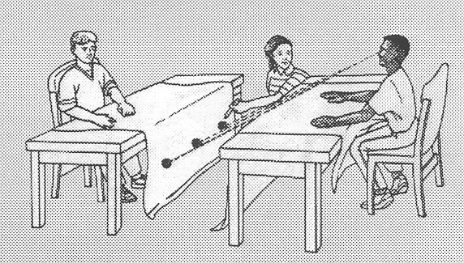
Figure 7: Table Model of the Grand Canyon

The canyon table activity turned out to hit the bull's eye. Right during the first try-out a beautiful lesson evolved with a class discussion that in a nutshell in fact revealed the core of the whole unit. Students discovered, guided by the teacher, that the vision of the person being in a higher position is better; that the vision line of that person is steeper; that in that case the blind area is smaller; that the angle between that person's vision line and the floor is larger; that the vision angle of that person is smaller; that moving a table will move the location of the blind area and broaden the river so that more of it becomes visible. This can be clarified by some quotations from students.

'One person is taller than the other one so they can probably see further down than the other, the shorter person could.'

'It's like, if your gonna be on the top looking down, you should be able to see almost straight down. If you were ten feet back from the sides of the wall you wouldn't be able to see anything straight down.'

'If you're leaning further, then you can see further down than when you're leaning back, because of the side ...'

Note that the way students put their notions into words is informal. They show their understanding of the factors influencing the view but struggle finding the right words. In this case it was the teacher who introduced the term 'vision line' as students were making movements with their hands to indicate how the person sitting behind the canyon table looks downward along the edge of the table. At that point one student used the words "from her eyes to the edge of the desk and then down". Also, it was the teacher who proposed to use a stick in order to model the vision line. When one of the students mentioned looking at a certain angle, it was again the teacher who required a precise indication of the angle that was meant. And when one student described the blind area (without naming it this way) as 'there where you cannot see' the teacher indicated that he wanted this area to be named 'blind spot.'
However, for the developers this did not imply that the design does not meet its expectations. For the intention is to stimulate students to reinvent mathematical concepts and to make explicit using their own words what the underlying mathematics is in a context they are familiar with. And according to the observations this is precisely what happened. It is fine if a teacher wants students to use mathematically correct terms to describe these findings. If a teacher starts fishing for one particular word that he wants to hear is less commendable.
Students quite often grab a certain mathematical concept before they actually 'discover' the appropriate language to describe it. The present example shows that students did indeed understand the mathematical concept in a very convincing way. They were also able to explain their 'inventions' in appropriate terms, but not (of course) in the appropriate mathematical language. In case of the vision line the students used gestures and descriptions in their own words, and when the teacher felt that it was appropriate he introduced the term vision line. In case of the blind spot students themselves came very close again: 'There where you cannot see.' This kind of mathematization processes very well fit our definition of reinvention.

By the way, the first try-out of the canyon tables activity described above brought up an interesting issue the developers had not thought of. The teacher asked students on each of the canyon walls to mark three point that were on the boundary of what could still be seen and what could not. Then, he asked the class to make a prediction of what these three marks on a canyon wall would look like. This resulted in three different 'theories' being brought up by students in the class discussion that followed. One theory was that all marks would be on a straight line at the same level; a second theory was that the mark in the middle would be further down than the marks on the sides; and the third theory was that it would be exactly the other way around, the mark in the middle being higher than the other two. For each of these theories there are possible implicit assumptions, such as: the assumption that the vision line is shorter if you look straight ahead, therefore you will see further down if compared to looking to the sides. Students may also have reasoned that you will see more if you look to the sides, for in the photograph of the hiker on the canyon rim it seemed likely that the hiker would see the river when looking aside instead of straight ahead, neglecting the fact that this was due to the fact that there was a curve in the river. In the try out of the activity the teacher offered students the opportunity to find out by themselves, which of these theories was correct. The students had to come to the conclusion that all marks had to be on a straight line, on the same level, if only the canyon walls were parallel to each other, no matter how long the canyon walls are.
As a result of these observations in the next version of the unit it was suggested to have students investigate this issue about the three marks on a canyon wall. But later experience tells us that such an investigation is only successful if students are really fascinated to find an explanation why these marks are on a straight line at the same level.

The canyon tables activity has proven to be very succesful in all subsequent classroom experiments, both in classroom settings where the activity was carried out with the whole class and in settings where students carried out the activity in groups of three or four. The canyon tables are a rich source for student exploration in which they can reinvent concepts worded in more or less explicit ways. From the most successful of the classroom experiments we may even state that the activity foreshadows all core concepts of the whole unit. As a consequence, throughout the learning processes that occur later on in the unit references can be made to students' experiences with the canyon tables. For example, the vision lines of the captain of the tug boat looking over the (straight!) bow all end on one line, in other words, the shape of the captain's blind area is the same as that of the bow of the tug boat. This is basically the same issue as the marks on the canyon wall across all being on the same level, on a straight line. An issue that will come up again in the context of shadows later on in the unit, when the end points of the shadows of the tree trunks that are on a straight line all form a straight line also.

Finally, there is one more observation related to the reinvention of vision lines that we want to mention at this point. It shows that it is not only possible for students to reinvent the concept of vision line but that a student may also come up with that particular name for the mathematical phenomenon all by himself. This is what happened at a school in The Netherlands where a try-out of the unit eventually took place.
The students were seated in groups of four, two by two behind 'canyon tables,' ready to do the canyon table activity described above. They first discussed the question concerning the photograph of the hiker on the rim of the canyon. In one of the groups the students spontaneously started to make drawings of the situation, some trying to draw perspective representations, others drawing side views. One student in his side view drew a line in order to determine that the hiker cannot see the river. Next to it, he had written 'vision line.' The observer asked him where that word came from, whether he himself had brought it up. He said that the teacher had just walked by asking him what that line was supposed to be, "and then I said, well, that is how he looks, and then I, well, then I call it vision line. A new word: vision line." Now this same student came to class very disappointed the next day, because looking through the unit at home he saw the word vision line was everywhere, so after all he had not invented a new word. But in fact he really had invented it all by himself: a prototype of reinvention.

This concludes the description of the developmental research into reinvention of the vision line at the beginning stage of students' learning process in the unit Looking at an Angle. A deeper understanding of what vision lines are, how they can be used to determine what can or cannot be seen by a person, and how to make precise drawing of vision lines requires many more student reinventions that have to be elicited during the learning process. The developmental research has resulted in many indications for further student reinventions. Especially observations of moments when students did or said unexpected things indicate where the hypothetical learning trajectory needs to be refined. At such moments it becomes clear that developer's assumptions were not correct.
We give a list of issues involving vision lines which have to be brought up during the learning process in such a way that students are enabled to make reinventions.
A vision line is a straight line. If you model a vision line with string it has to be done in such a way that it is really straight, not bent. From the eye of the person looking at something there are numerous vision lines possible, however, not all of these are relevant in order to determine what this person can or cannot see. In order to see something the person looking needs to look into the right direction. A vision line starts from the eye and ends at the object that is seen. A vision line cannot go through objects for you cannot see through things. However, on paper it is possible to draw a vision line through an object, even though that is not realistic. (That is a legitimate method to determine whether or not a person can see an object. You may draw a side view with a straight line from the eye of the object. If that line goes straight through an object such as rock, this proves that the person cannot see the object since the view is blocked.) Vision lines may be drawn in perspective representations of a situation, but also in top, side, or front views. However, each of these drawing contains different information so you have to be careful in selecting a useful representation. For example in a top view you may draw the direction of a vision line but this does not tell you where it stops; for that purpose you need a side view.

Conclusions

In this chapter we described how a learning environment that promotes reinvention of the concept of vision line was constructed. Based on the developmental research we may conclude that the final product indeed enables students to reinvent this concept. According to the observations it is however clear that we may not expect the same level of success in all circumstances. Success to a large extend depends on the knowledge and teaching qualities of the teacher; on students' previous learning experiences; and on facilities offered by the school, such as time, materials and room. Implemention issues require a great deal of attention.

As far as the final product is concerned the developmental research was successful. Equally important is the process through which this goal was accomplished and the knowledge that accumulated. We conclude that the developmental research was of enormous value to the creation of the final design. Besides, the cyclic process of design, data collection and analysis, and revision has resulted in a large amount of experience which may be utilized for further developmental research in the area of realistic geometry education.
Designing a hypothetical learning trajectory appears to be a first and most important step. Thanks to the students and the teachers involved in the research who have offered the researchers the opportunity to analyze their learning and teaching processes, it was possible to put the thought experiment to the test and to continually refine and improve the learning trajectory.

Literature

Feijs, E. & J. de Lange (1994). Een andere koers in het Amerikaanse meetkundeonderwijs. Tijdschrift voor nascholing en onderzoek van het reken-wiskundeonderwijs, 12 (4). 25-32.

Freudenthal, H. (1973). Mathematics as an Educational Task. Dordrecht: Reidel.

Freudenthal, H. (1988). Ontwikkelingsonderzoek. In: K. Gravemeijer en K. Koster (eds.). Onderzoek, ontwikkeling en ontwikkelingsonderzoek. Utrecht: OW&OC.

Freudenthal, H. (1991). Revisiting Mathematics Education. Dordrecht: Kluwer Academic Publishers.

Freudenthal, H. (1983). Didactical Phenomenology of Mathematical Structures. Dordrecht, Reidel.

Glaser, B.G. & A.L. Strauss (1967). The Discovery of Grounded Theory: Strategies for Qualitative Research. New York: Aldine. 101-115.

Gravemeijer, K. (1994). Developing Realistic Mathematics Education. Utrecht: CD b Press.

De Lange, J. de. (1980). Vlieg er eens in. Utrecht: IOWO.

De Lange, J. de (1991). Flying Through Math: Trigonometry, Vectors, and Flying. Scotts Valley: Wings for Learning.

De Lange, J. en E. Feijs (1994). Verschillende koersen leiden tot een hoek. Tijdschrift voor nascholing en onderzoek van het reken-wiskundeonderwijs, 13 (2). 10-15.

Feijs, E., Lange, J. de, Reeuwijk, M. van, Spence, M.S. & Brendefur, J. (1998). Looking at an Angle. National Center for Research in Mathematical Sciences Education & Freudenthal Institute (Eds.), Mathematics in Context, A Connected Curriculum for grades 5-8. Chicago: Encyclopaedia Britannica Educational Corporation.

National Council of Teachers of Mathematics (1989). Curriculum and Evaluation Standards for School Mathematics. Reston, VA: NCTM.

Romberg, T.A. (ed.). A Blueprint for Mathematics in Context: A Connected Curriculum for Grades 5-8. Madison: NCRMSE.

Schoenmaker, G., A. Goddijn, J. de Lange & M. Kindt (1981). Neuer Geometrieunderricht auf der Sekundarstufe. In: H.G. Steiner & B. Winkelman (eds.). Fragen des Geometrieunderrichts. Köln: Aulis Verlag Deubner & Co KG. 99-156.

Streefland, L. (1990). Free Productions in Teaching and Learning Mathematics. In: K. Gravemeijer, M. van den Heuvel and L. Streefland. Contexts, Free Productions, Tests and Geometry in Realistic Mathematics Education. Utrecht: OW&OC. 33-52.

Team W12-16. (1992). Achtergronden van het nieuwe leerplan wiskunde 12-16. Band 2. Utrecht: Freudenthal Instituut, Enschede: SLO.

The curriculum materials are published by Encyclopaedia Britannica Educational Corporation, Chicago Il, VS.
Freudenthal, H. (1988). Ontwikkelingsonderzoek. In: K. Gravemeijer en K. Koster (eds.). Onderzoek, ontwikkeling en ontwikkelingsonderzoek. Utrecht: OW&OC. 52.
Freudenthal, H. (1973). Mathematics as an Educational Task. Dordrecht: Reidel. 100.
Gravemeijer, K. (1994). Developing Realistic Mathematics Education. Utrecht: CD β Press. 112.
Gravemeijer, K. (1994). Developing Realistic Mathematics Education. Utrecht: CD β Press. 113.
Glaser, B.G. & Strauss, A.L. (1967). The Discovery of Grounded Theory: Strategies for Qualitative Research. New York: Aldine. 101-115.
Feijs, E. & J. de Lange (1994). Een andere koers in het Amerikaanse meetkundeonderwijs. Tijdschrift voor nascholing en onderzoek van het reken-wiskundeonderwijs, 12 (4). 25-32. De Lange, J. & E. Feijs (1994). Verschillende koersen leiden tot een hoek. Tijdschrift voor nascholing en onderzoek van het reken-wiskundeonderwijs, 13 (2). 10-15.
Freudenthal, H. (1983). Didactical Phenomenology of Mathematical Structures. Dordrecht, Reidel.
De Lange, J. de. (1980). Vlieg er eens in. Utrecht: IOWO. Or: De Lange, J. de (1991). Flying Through Math: Trigonometry, Vectors, and Flying. Scotts Valley: Wings for Learning. The mathematical content of this unit involves vectors, sine, cosine and tangent. 'Looking at an Angle' is inspired by the first chapter only.
Gravemeijer, K. (1994). Developing Realistic Mathematics Education. Utrecht: CD β Press. 100-102.

